

**ÇANAKKALE ONSEKİZ MART ÜNİVERSİTESİ**

**BİLGİSAYAR MÜHENDİSLİĞİ**

**Nesneye Dayalı Analiz ve Tasarım Dersi**

**Proje Adı:**

Lokanta Sipariş sistemi ( Restaurant Ordering System : ROSys )

**Rapor 3:**

Domain Models

**Grup No:** 06

**Grup Adı:** Firestone

**Grup Üyeleri:**

**Amer Sawan (130401073)**

**Abdoul Karim Touré (130401078)**

**DANIŞMAN: Yrd. Doç. Dr. Ali Murat Tiryaki**

Çanakkale 2017

**İçerikler:**

Conceptual Class Category 1

Use-Caes Domain Models 1

Use-Case 1 Domain Model 1

Use-Case 2 Domain Model 2

Use-Case 3 Domain Model 3

# **Conceptual Class Category**

|  |  |  |  |
| --- | --- | --- | --- |
| **Conceptual Class Category** | **UC1** | **UC2** | **UC3** |
| **Business transactions** | *** | Payment | *** |
| Guideline: These are critical (they involve money), so start with transactions. |
| **Transaction line items** | FoodLineItem | FoodLineItem | FoodLineItem |
| Guideline: Transactions often come with related line items, so consider these next. |
| **Product or service related to a transaction or transaction line item** | Food | Food | Food |
| Guideline: Transactions are for something (a product or service). Consider these next. |
| **Where is the transaction recorded?** | Ledger | Ledger | *** |
| Guideline: Important. |
| **Roles of people or organizations related to the transaction; actors in the use case** | Customer | Personel, Customer | Chef |
| Guideline: We usually need to know about the parties involved in a transaction. |
| **Place of transaction; place of service** | Restaurant, Table | Restaurant, Table | Restaurant |
| **Noteworthy events, often with a time or place we need to remember** | Order | Receipt, Payment | *** |
| **Descriptions of things** | FoodDescription | FoodDescription | FoodDescription |
| **Catalogs** | FoodCatalog | FoodCatalog | FoodCatalog |
| Guideline: Descriptions are often in a catalog. |
| **Containers of things (physical or information)** | Restaurant | Restaurant | Restaurant |
| **Things in a container** | Food | Food | Food |
| **Other collaborating systems** | *** | CreditAuthorizationSystem | *** |
| **Records of finance, work, contracts, legal matters** | *** | Receipt, Ledger | *** |
| **Financial instruments** | *** | Cash, LineOfCredit | *** |

# Use-Caes Domain Models

## Use-Case 1 Domain Model

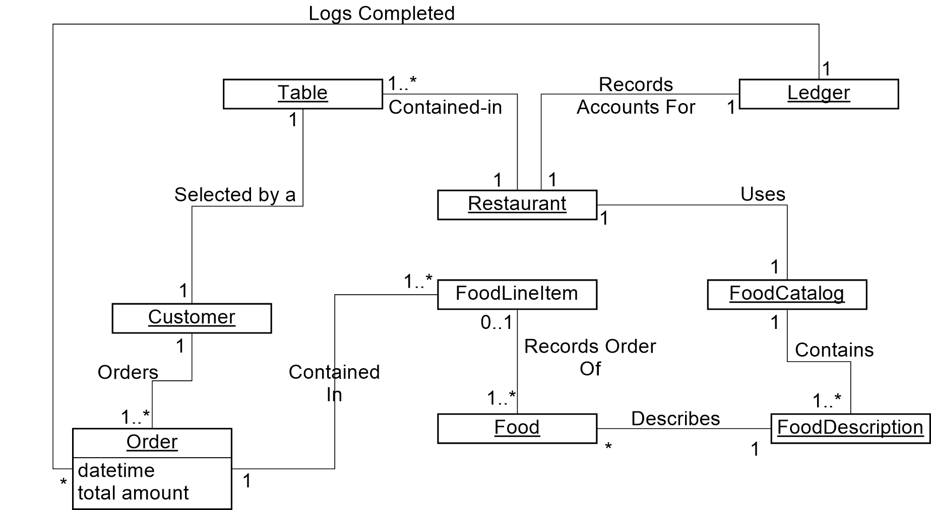

## Use-Case 2 Domain Model

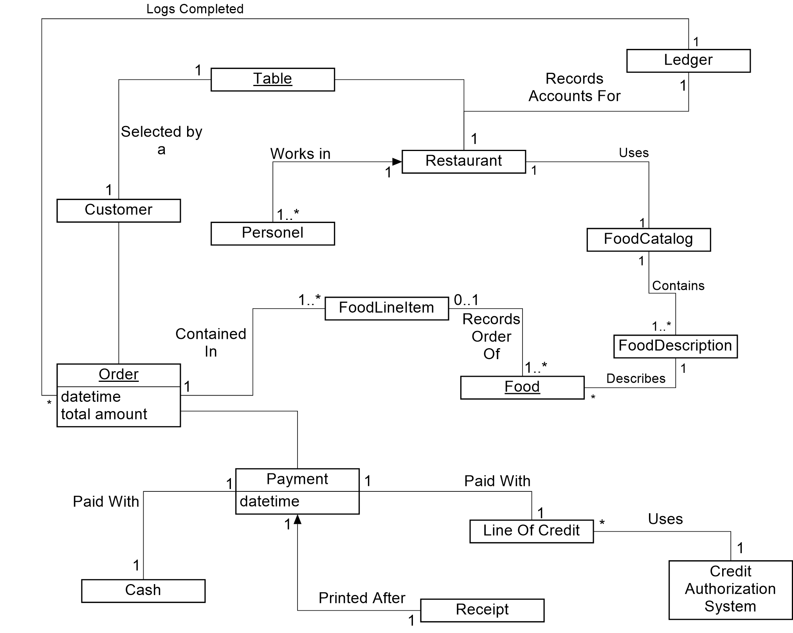

## Use-Case 3 Domain Model

